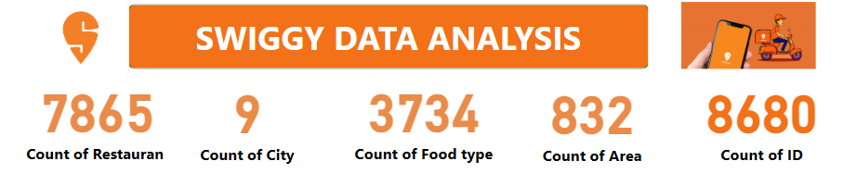

**TOP 10 AREAS WITH HIGHEST NUMBER OF RESTAURANT**: **GEOGRAPHIC RESTAURANT LOCATION:**

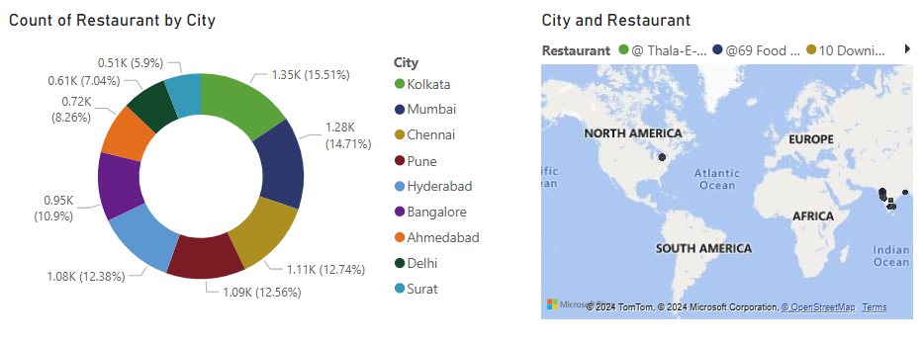

**From this pie chart, we know that Kolkata, Mumbai, Chennai, Pune, Hyderabad, Bangalore, Ahmedabad, Delhi , and Surat are the 10 cities with more restaurants**

**From this pie chart, we know that Kolkata, Mumbai, Chennai, Pune, Hyderabad, Bangalore, Ahmedabad, Delhi , and Surat are the 10 cities with more restaurants**

**Here is a geographical representation of the restaurant**

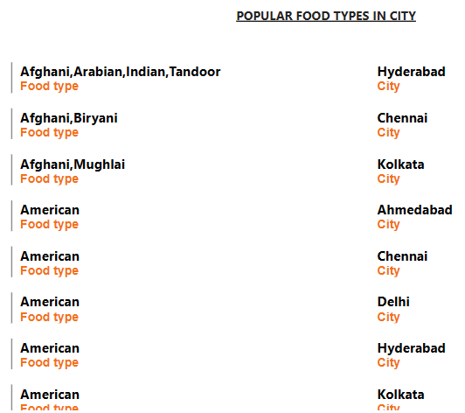

**Here in this multi-row card chart, we get to know the food type served by each city  
Example: In Hyderabad, they serve afghani, Arabian, Indian, and Tandoor types of food**

**PRICE ANALYSIS:**

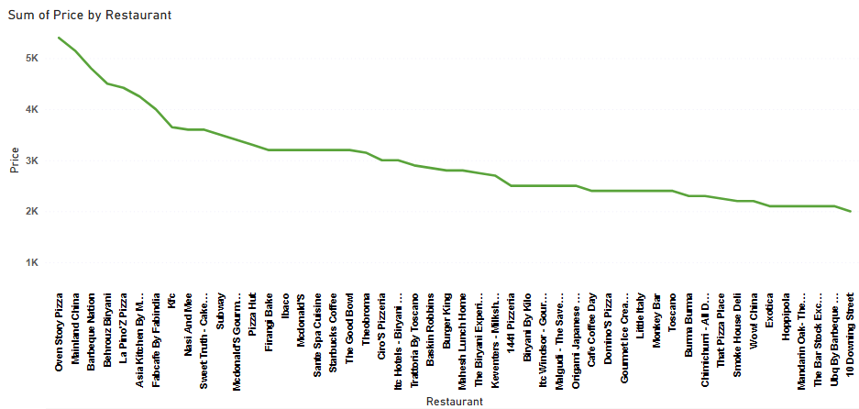

**In this line graph, we have the price analysis of each restaurant from which we can analyse that Oven story pizza is the most expensive price restaurant**

**TOP RATED SWIGGY RESTAURANT:**

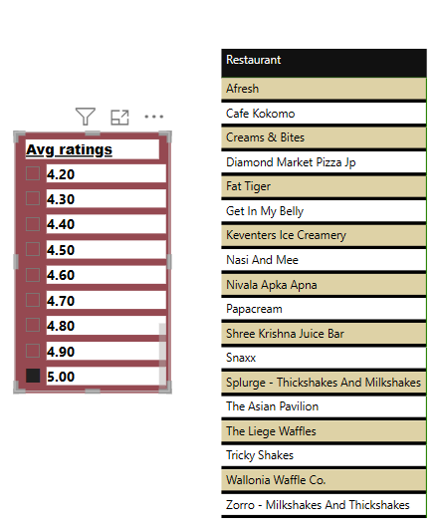

**Here are the top 18 swiggy delivery restaurants with an average rating of 5**

**CORRELATION OF FACTORS BETWEEN PRICE AND RATING:**

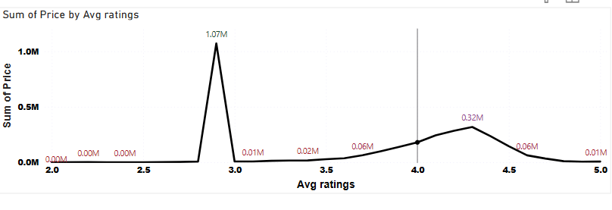

**This is the correlation of price and rating, in some cases the rating is low because of the high price, but in some cases the rating is high and the price is low, it may depend on the taste of the food**

**CORRELATION BETWEEN RESTAURANT PRICE AND RATING:**

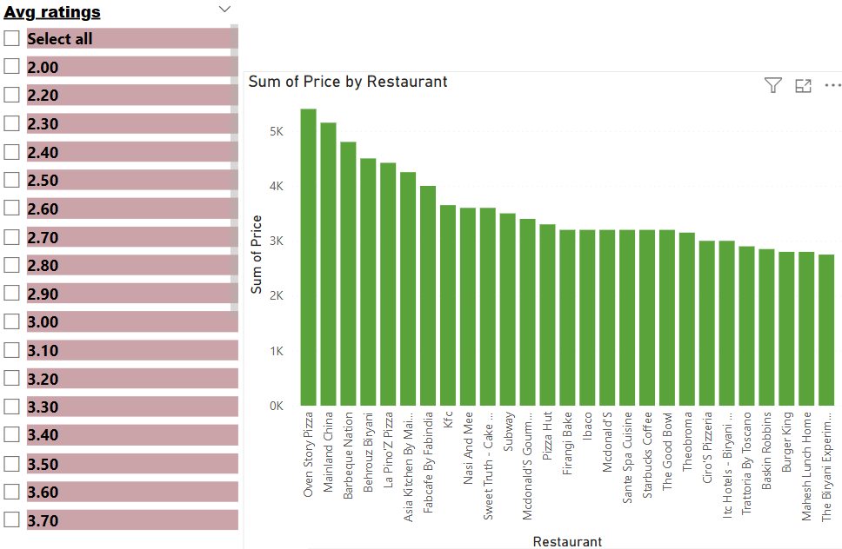

**Here is the relationship between average rating and restaurant price.**

**CITY WISE RESTAURANT COUNT:**

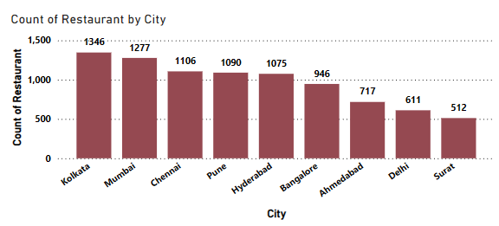

**This is the city-wise restaurant count bar chart from this we know that in Kolkata 1346, in Mumbai 1277 in Chennai 1106 respectively.**

**AVERAGE DELIVERY TIME:**

**DELIVERY TIME ANALYSIS:**

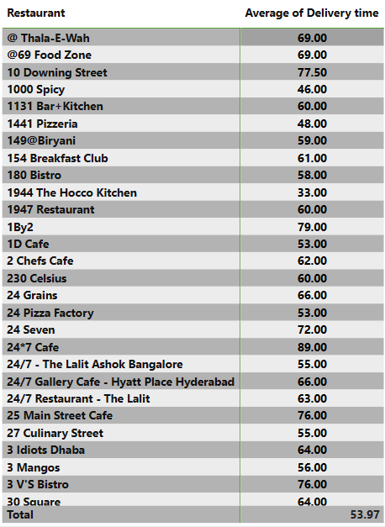

**Here we can analyse the average delivery time of our food order, based on this information, 1944 Hocco kitchen delivers the order faster than other restaurants and 24*7 Café takes longer**

**AREA WISE RESTAURANT ANALYSIS:**

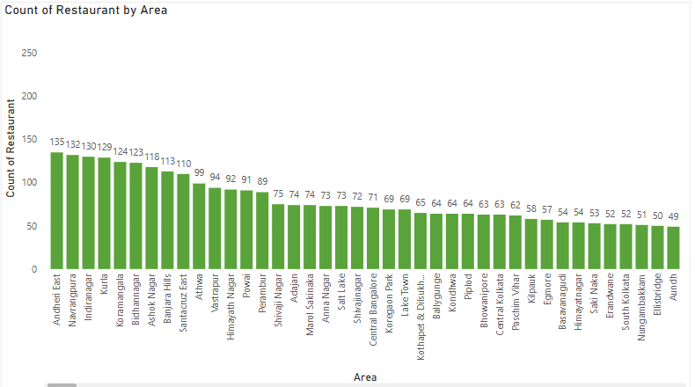

**Here is the area wise restaurant number of Andheri East has more restaurants**

**CUISINE ANALYSIS:**

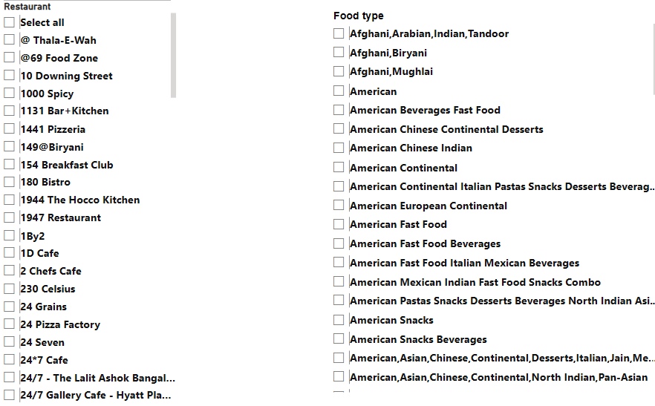

**Here the data which shows the variety of cuisine offered by each restaurant**

**CUSTOMER FEEDBACK ANALYSIS:**

**Based on this information, we know that Swiggy is the largest and most popular food-ordering platform in India. Swiggy offers many options and provides smooth and fast service to customers. Customers can get food from their favorite restaurant at home and enjoy it in peace. Customers are happy with Swiggy because it is available in every big and small city and provides excellent service everywhere. Customers were satisfied with the fast delivery.**

**BUSINESS RECOMMENDATION:**

**From this data analysis, my recommendation to develop a business is to decrease the price and delivery time**

**For the restaurant that has a low rating, it may be because of price, Taste, delivery time, a package of food, etc., In this case, the restaurant should concentrate on food taste why because if the price of the food is a little bit high and the taste is good means the customer will feel like it is worth the money, and the secondary thing is the delivery time**

**SWIGGY ANALYSIS DOCUMENTATION**

